**Programming Fundamentals**



|  |  |
| --- | --- |
| Name | Ali Salman |
| Registration Number | FA22-BCE-005 |
| Class | BCE- 2A |
| Instructor’s Name | Dr. Omar Ahmed |

***Lab # 04***

***Working with State Machines and Different Data Types***

**In Lab:**

**Task 1:**

Write a C program that solves a simple user-entered mathematical expression. It should take input from the user (two floating type values and operations like *, /, + and -), calculate the result and show it on screen. e.g. if the user inputs “5 + 6” the program should add numbers 5 and 6 and print the answer 11 on to the console.

**Program code:**

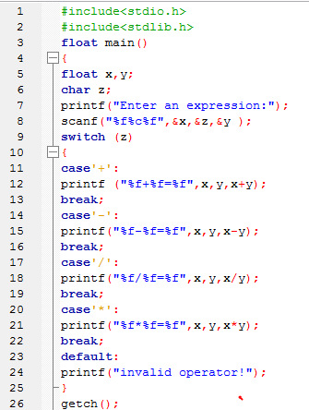

**Output:**



**Task 2:**

Following program prints a menu. It then takes input from user and displays the entered choice. Type-in the C program given below into a new project, compile and run to see how it works.

**Program code:**

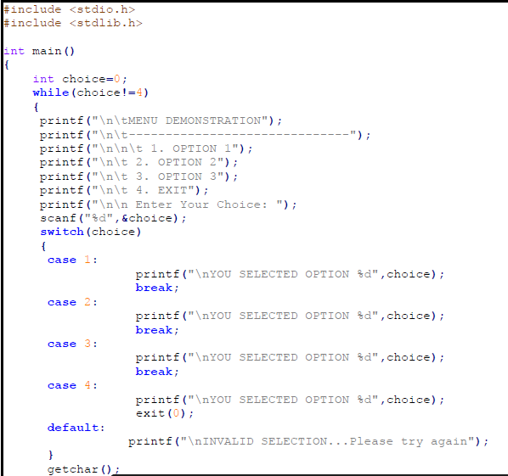

**Output:**

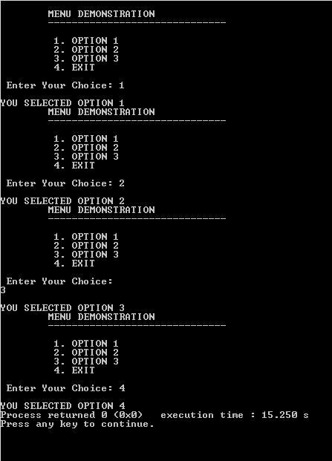

**Task 3:**

Modify the above program to implement following sate machine. Here *‘a’* and *‘b’* are user input characters. The program should print out appropriate messages to the console when a user enters a character.

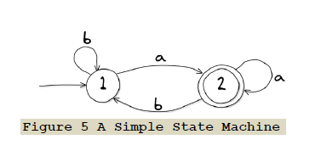

**Program code:**

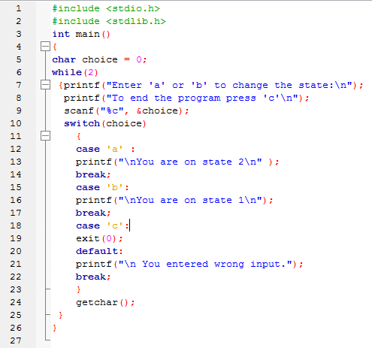

**Output:**

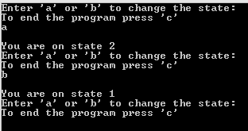

**Post lab task:**

Write a program to implement the following state.

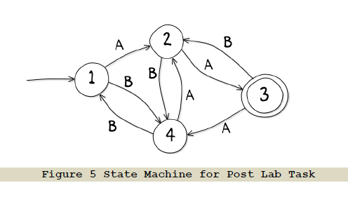

**Program code:**

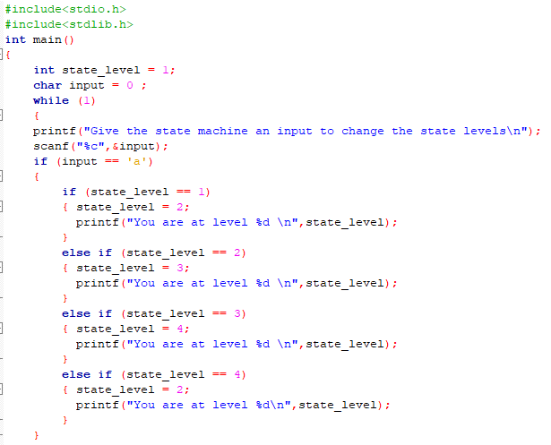

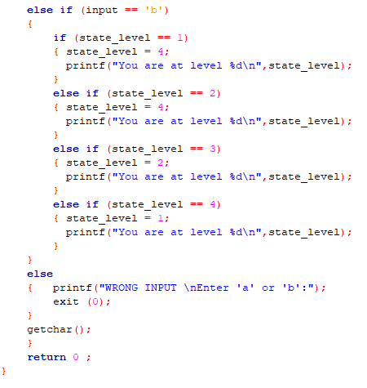

**Output:**

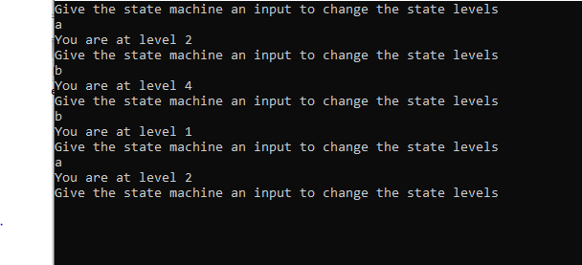

**CRITICAL ANALYSIS:**

In this lab, we learn a new library file “string.h”. We understand the working of finite state machine and how nested loops are used to make state programs and also about different data types. We learn the basic concept of finite state machine and how it works.